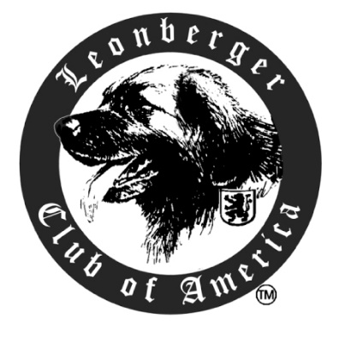 2026 LCA National Specialty

Boulder Falls Inn Event Center
505 Mullins Dr
Lebanon, OR 97355

Vendor Reservation Form

Vendor Space Manager: Ginny Bartholomay
Vendor rates are $100 for the event May 5 – May 9, 2026. Standard table spaces are 10’x10’ although other sizes may be available. Space is limited and reservations are accepted on a first come, first served basis. The rate includes the booth space only; tables & skirting are available for additional cost. Payment must accompany your reservation form and is non-refundable after April 5th, 2026. Vendors will be located inside the event center. The Specialty Committee reserves the right to determine vendor location and space. Note: No signs, banners, or decorations may be affixed to the walls or doors of the hotel or event center. Booth will be available for set-up on Tuesday (5th) at Noon. All vendors must take down their booths and be moved out by 6pm Saturday May 9, 2026.

To reserve vendor space or other related questions, contact:
Ginny Bartholomay @ 847-612-0045
vbartholomay@gmail.com

Name: __________________________________________
Address: __________________________________________
City, State, Zip: __________________________________________
Phone: __________________________________________
Email: __________________________________________
Booth Name*: __________________________________________
*The name of your booth and address or website will be included in the information given to exhibitors.

_____ Number of spaces @ $100.00 each.
_____ Draped table and 2 chairs @ $30.00 for the event.
_____  Electric @ $25.00

$_______ Total enclosed

You can pay online at: https://www.lca-specialty.com/vendor or send a check payable to Leonberger Club of America.
Mail to: 2026 LCA National Specialty
Nadine Love-Filer
N6044 Johnson Road Burlington
Wisconsin 53105-2911

We are also requesting a donation to our general raffle or auction.

